Tobi Swinbank Memorial Netball Tournament 2013

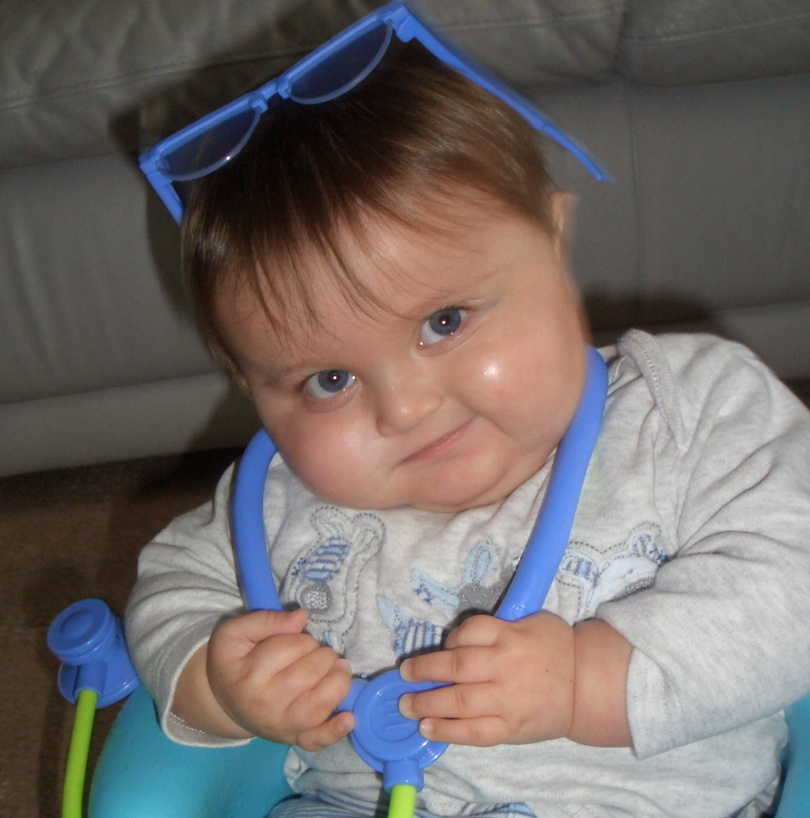

On Saturday 22nd June at Blue Flames sporting club saw 15 teams take part in this years annual Tobi Swinbank memorial netball tournament. The event was sponsored by Future Strategies LTD allowing all money raised from this event to go directly to the RVI children’s kidney fund.
Tobi Swinbank was diagnosed with renal failure aged 14 days old and due to complications died aged 18 months in 2010. In his memory and raising money for continued research and support this event raised a total of £1463.20

The 2013 winners of the Ladies League as pictured were Seatonians who beat Newcastle City in the final.

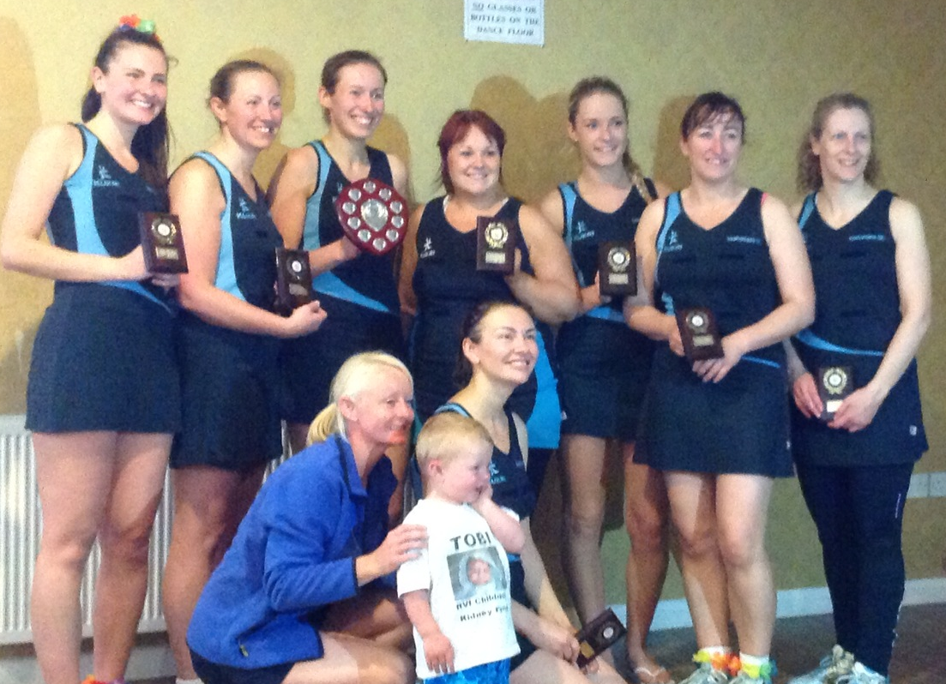

The 2013 winners of the Mixed League were Deloitte. Runners up were the Magpies.

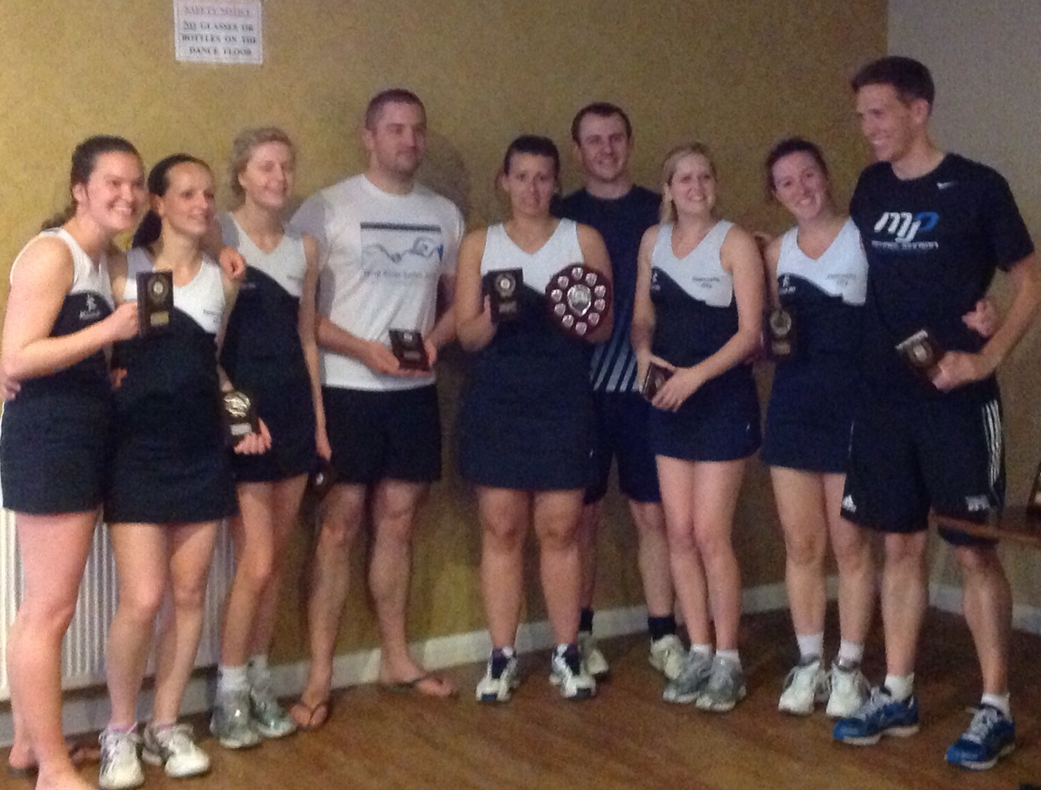

The 2013 winners of the Wooden Spoon Trophy were team RVI made up from staff who have cared for Tobi on the ward.

